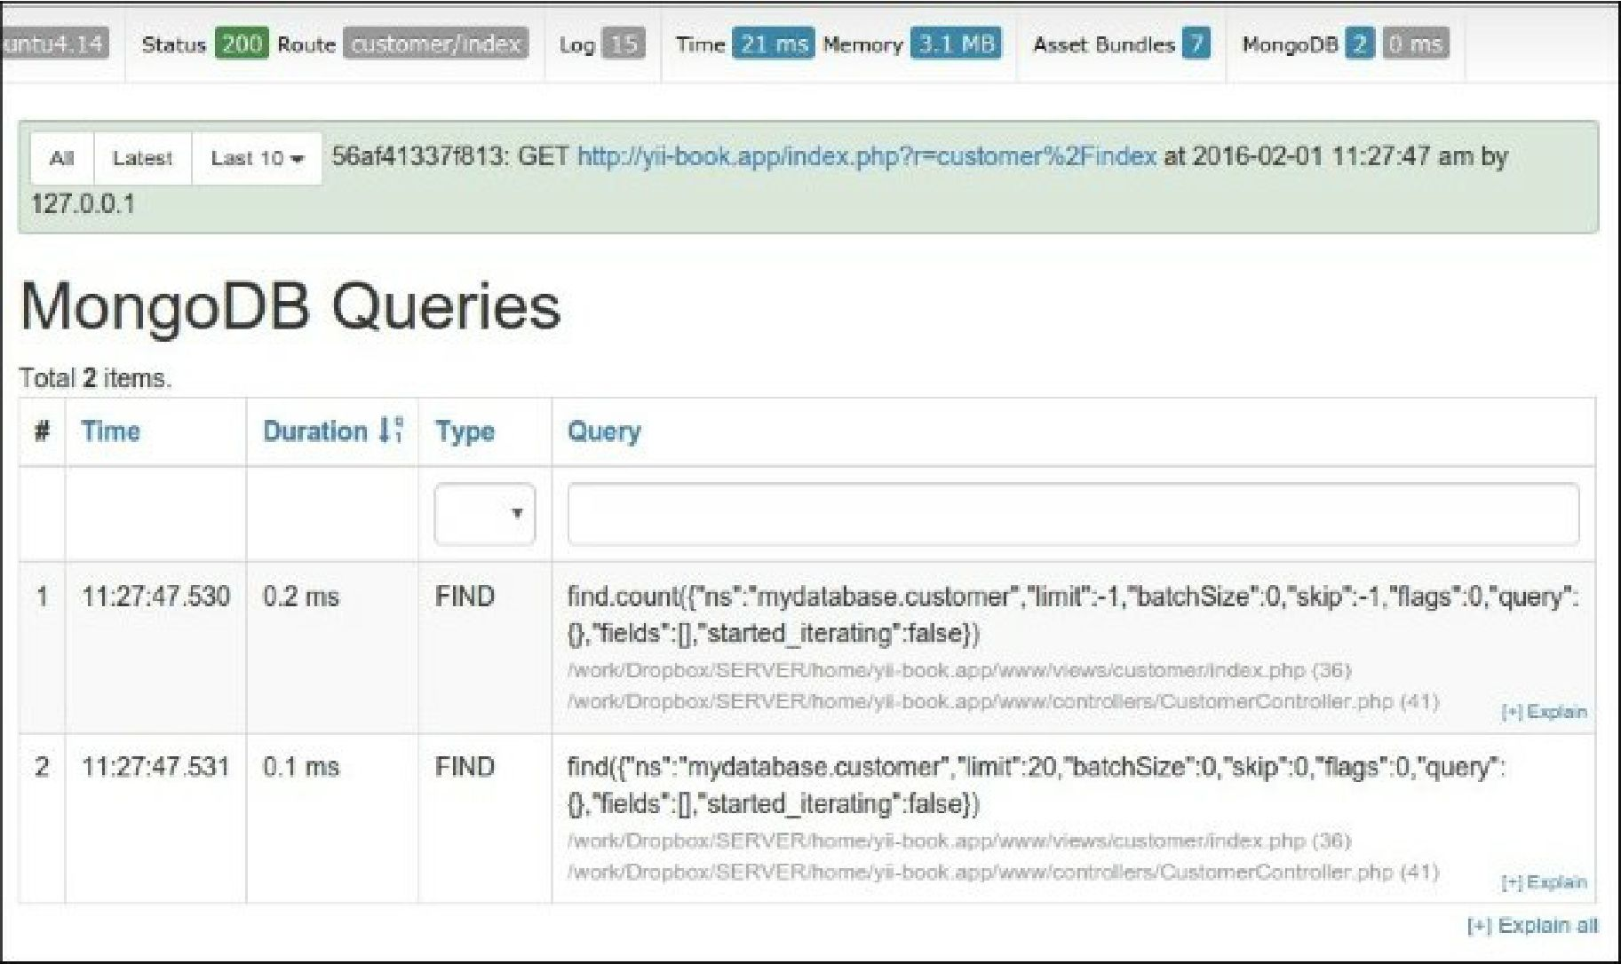

Basic usage

You may access databases and collections via the \yii\mongodb\collection instance:

$collection = Yii::$app->mongodb->getCollection('customer');$collection->insert(['name' => 'John Smith', 'status' => 1]);

To perform the find queries, you should use \yii\mongodb\Query:

use yii\mongodb\Query;

$query = new Query;

// compose the query $query->select(['name', 'status'])

->from('customer')

->limit(10);

// execute the query $rows = $query->all();

Note

Note: The MongoDB document id ("_id" field) is not scalar, but an instance of the \MongoId class.

You must not care about the conversion from integer or string $id values to \MongoId, because query builder converts it automatically: $query = new \yii\mongodb\Query; $row = $query->from('item')